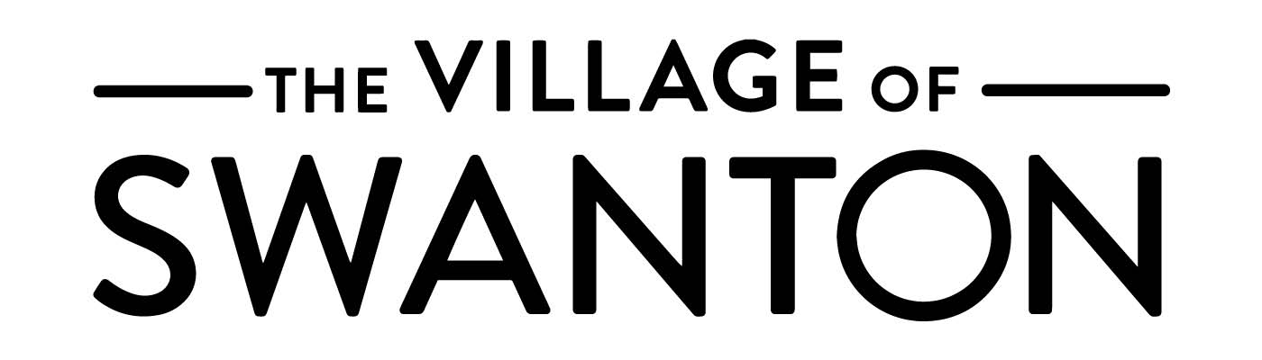
Planning Commission
Meeting Agenda
August 7, 2018 ⦁ 6:30 p.m.

- Call to Order

- Roll Call: Mr. DeGood, Mr. Dzyak, Mr. Erdman, Mayor Roth, Mr. Young

- Approval of Minutes: July 3, 2018

- Public Hearing
  - 110 Brookside
    - Variance Request
      - Acknowledge applicant, or representative, to speak on behalf of application
      - Acknowledge those who wish to speak in support of application
      - Acknowledge those who wish to speak in opposition of application

  - Metroparks Toledo 3520 Waterville Swanton
    - Site Plan Review
    - Variance Request
      - Acknowledge applicant, or representative, to speak on behalf of application
      - Acknowledge those who wish to speak in support of application
      - Acknowledge those who wish to speak in opposition of application

- Zoning Staff Report

- Open Forum

- Adjourn

